**Select CNH Vendors:** The Select CNH Vendors tab allows you to customize what parts orders you can view in the HBS Open Orders tab by selecting which CNH vendors you want to view orders to. For example, if you want to see only orders to New Holland and Case, select those two boxes as in the image above, make sure all other boxes are deselected, and click **Save**. Only orders to New Holland and Case should then appear in the HBS Open Orders tab.

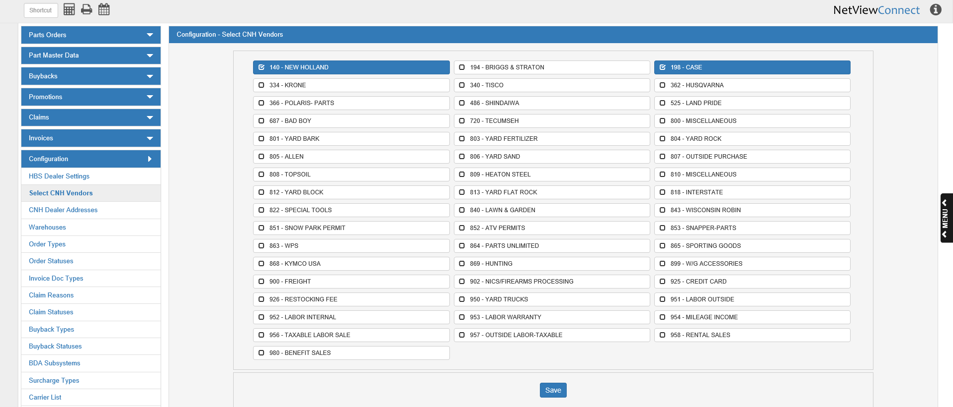

**NOTE:** The following vendors will be selected by default when the program is first opened:

* 140-New Holland
* 156-Kobelco
* 198-Case
* 312-Miller/Pro Badger
* 259-Flexicoil